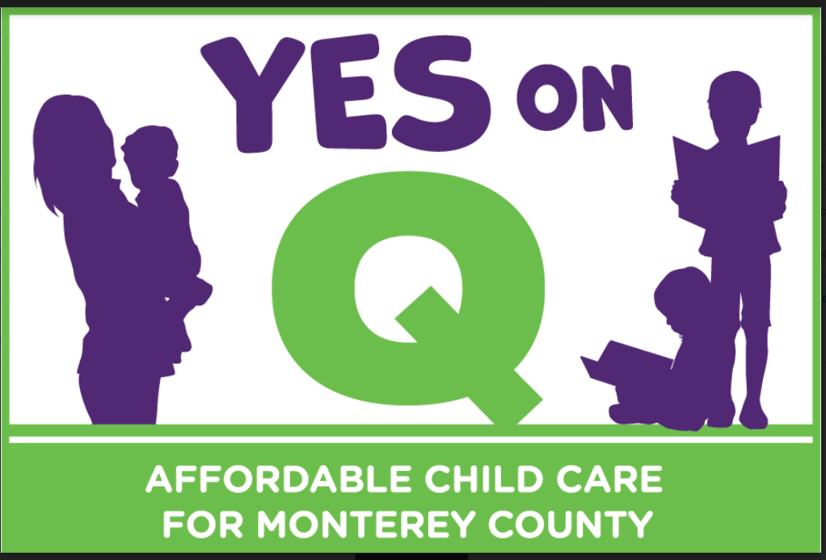

Measure Q – Safe, Affordable, Quality Child Care in Monterey County Act
Frequently Asked Questions
Why is it so urgent today to solve the problem of lack of affordable child care in Monterey County?
Despite being a great place to live, work and visit, Monterey County faces several challenges. Parents need to work and children need the best start possible. But too many local workers can’t access the safe, affordable, quality child care needed for their children.
There are only 9,200 slots for the 36,000 children under 5 in the county, and child care costs average more than $10,000 a year. This makes child care both hard to find and unaffordable for most families.
How are these issues affecting young children and families in Monterey County? Research shows that 90% of a child’s brain develops before age five, laying the foundation for the rest of their life. Unfortunately, only one in four children in Monterey County is ready for kindergarten because too many families lack access to quality early childhood education.
By expanding access to these services, we can strengthen families and help ensure that every child in Monterey County has the early literacy and math skills they need to start school ready to succeed.
Quality, affordable child care is especially important for children who are experiencing trauma, such as homelessness, abuse or neglect, and family stress.
How will revenue from a countywide funding measure be used?
Measure Q will raise $5.5 million annually, under local control to:
- Increase availability, affordability and access to licensed child care;
- Attract and retain qualified educators and caregivers;
- Improve the safety and quality of licensed child care.
Are there more details on how the money might be spent?
Some of our local priorities include:
- Adding care for shift workers in agriculture, hospitality, health care and other local industries.
- Building centers that are near employment centers and have easy access to transportation.
- Supporting innovative programs to attract and train more qualified child care teachers and staff, such as earn-to-learn programs that get teachers into the child care and education settings right away, making more child care available sooner.
- Reduce barriers to entry for new child care and education businesses, such as availability of appropriate facilities and capital for start-up.
- With more facilities, draw down more State and Federal child care subsidies so more families can receive free or low cost care.

How do we know the funding will be spent responsibly?
The measure includes strict fiscal accountability protections, including:
- All money raised under the Act will be locally controlled and be spent only in Monterey County to expand and improve safe, affordable, quality child care and early education opportunities for young children
- No funds can be taken away by the State
- Sunsets automatically in ten years
- Requires community oversight by a broad spectrum of stakeholders - including parents, business leaders, educators, and taxpayer advocates.
- The early childhood expert First 5 Monterey County, will manage the funds. It is an independent public agency with its own strategic plan, advisory committees and independent staff. It is required to hold public meetings, perform annual audits and have public disclosure of spending. These funds will be included in those audits and disclosures.

- Will Measure Q require a formal audit?
- The Measure itself calls for the Auditor-Controller to file an annual report with the Board of Supervisors describing both of the following:
- A. The amount of funds collected and expended; and
- B. The status of any project required or authorized to be funded by the Measure

- First 5 Monterey County is REQUIRED by law to perform annual independent audits of all funds received. These funds are required to be included in those audits. Therefore, the funds will be independently audited.

Wait: Are there 2 Measure Qs?
Unfortunately there is a Measure Q in San Benito County also, and it is a debate about land use. So, if you hear any ads or see signs related to development or environmental issues, those have nothing to do with our Measure Q for Monterey County.
Where is Measure Q on my ballot?
Don’t Stop at the Top: As the ONLY countrywide-ballot measure, Q is located on the second side of the "Measures Submitted to the Voters" page. Remember to flip that page over and Vote for Q on the second side!
How will the Oversight Committee work?
The Oversight Committee is structured based on the same, successful model as used for the TAMC ballot measure, and is subject to the Brown Act. It will have 15 diverse members that are residents of Monterey County, must be vetted through an application process, and have three-year terms. They will represent all geographic regions of the county, have a working understanding of the needs of parents and children, child care and education providers, local business and economic development, and taxpayers.

The Committee must be in place within six months of the effective date of the Act. It will develop a Program Plan and Program Budget which will be approved through a public process with the First 5 Monterey County Commission. The Committee will oversee the implementation and evaluation of the designated projects, and is required to provide an annual report. All reports will be available for public review.
How will this measure support our local economy?
People are eager to return to work to support themselves and their families. But too many local workers can’t access the safe, affordable, quality child care and preschool needed for their children while they return to their jobs.
It’s time to address this problem now—especially as local employers are eager to hire local workers for important jobs in hospitality, agriculture, healthcare and other vital local industries.
Improving access to safe, affordable, quality child care is a wise investment. Research shows that for every dollar invested in early childhood programs, the community benefits through higher graduation rates, lower incarceration rates, less crime and lower healthcare costs.
Doesn’t the State provide early child care education and services?
State and Federal funding for quality, local early childhood education and services consistently falls short of the needs of Monterey County children, families and employers. Now, more than ever, we need local funding for these critical services. We cannot depend on unreliable State and Federal funding to address these urgent needs within our communities.

Is it the government’s role to be involved in preschool education and child care? What about parental choice?
All child care and preschool programs are optional and families choose where, when and how to support their children best. Most child care is provided by nonprofits and private businesses. Measure Q will not change that. In fact, additional support for child care is a way to create more small business opportunities in our county and increase parental choice for their preferred type of care.

- Who will qualify for the child care service?
- Measure Q will provide support to the overall system of child care by:
  - attracting and retaining qualified educators and caregivers. It will expand the child care workforce for a variety of child care settings and income levels. By supporting apprenticeship programs (earn as you learn) and reducing barriers to entry for child care providers, Measure Q will expand the workforce for public, private, center based and home child care settings. Families regardless of income will benefit from this expansion of the workforce and child care offerings.
  - expanding the overall availability of licensed child care facilities and homes. Public, private, center based and home based providers will be supported with access to business supports and quality enhancements.
  - expanding the availability of subsidized care. Many people do not know that the income qualifications for child care subsidies have been increased. Now, for example a family with one or two parents and one child can earn as much as $84,000 and qualify for subsidized care. [See this resource for additional information on income qualifications: Subsidized Child Care Services] The problem is that we don't have enough child care facilities! Monterey County has not been able to qualify for all the subsidies we need because we have not had the facilities or staff to apply for them. Therefore, there are LONG waiting lists of people who could benefit from subsidized care but can't because we simply do not have enough spaces.
Why doesn't the measure include providing affordable child care?
- The Measure does include an increase in availability, affordability and access to licensed child care. By expanding more facilities and child care homes, Monterey County can draw down more State and Federal child care subsidies so more families can receive free or low cost care. There are many more families that qualify for subsidized care than can find it. By expanding our supply of care, more families who currently qualify for subsidized care will be able to access it. In addition, we are also seeing a shift in the way employers think about the importance of child care. They are recognizing that supporting their staff to access quality affordable child care is good for their bottomline and are supporting creative solutions for expanding child care near their offices.
How much would the measure cost?
The parcel tax measure would cost $49 per year for 10 years and generate $5.5 million annually.
Is $5.5 million a year enough to solve this problem?
The beauty of these dollars is that they are local and flexible. They will help us leverage and be able to access State and Federal funding that has historically been left on the table, and lost to other counties. For example, providers have not been able to serve the total number of children that have been authorized by the State because there has not either been the staff or the space to provide care. We have not even had the capacity to apply for some state and federal dollars. Measure Q will help us build that capacity. These dollars will also be a consistent funding source as opposed to one-time, inconsistent, and/or year to year funding that is hard to plan around and are an important part of solving this problem.
In fact, Measure Q will leverage private, state and federal dollars towards the goal of doubling child care and early learning spaces for children under 5. Measure Q will also fill gaps in current funding and leverage other dollars to expand child care. The funding can ONLY be used to support the expansion and improvement of child care in Monterey County.

The Measure states that parcels under Section 205.5 of the Cal. Revenue and Taxation Code are exempt. What does that include?
Homes that qualify for disabled property tax exemptions.

What are the other exemptions?
The other exemptions include:

  - Parcels that are already fully exempt from ad valorem property taxes under California law including:
    - State and local government property
    - Public libraries and museums that are free and open to the public
    - Cemeteries
    - Churches
    - Schools, community colleges, state colleges, and state universities, including faculty and student housing on public land
    - Welfare exemption: volunteer fire departments, property used for nonprofit religious or charitable purposes, certain nonprofit housing and related facilities for elderly, handicapped, or low-income families, certain emergency or temporary shelter and related facilities for homeless people, nonprofit hospitals and housing owned by any of the aforementioned categories
    - Leased property used for low-income rental housing
- Parcels that constitute land used in Section 56016 of the California Government code as land used for growing crops. Land used for ag processing and/or commercial use are not exempt and will be taxed under the Measure.
- Parcels used as a licensed family child care home.
Would this mean that nearly ⅓ of the parcels in the county would be exempt from the parcel tax as some have claimed?
No, a total of less than 8% of the parcels in the county would be exempt.
How can I vote YES on Q this November?
To check your voter registration status, visit www.registertovote.ca.gov .

How many votes are needed to pass the Safe, Affordable, Quality Child Care Act? Because it is a community initiative that collected signatures to qualify for the ballot, we need majority voter support (50% +1 vote) in order to win.
How can I help or show my support?
To show your support for Measure Q, please add your name to our growing list of public supporters by completing our short online form HERE [hyperlink]
http://tinyurl.com/Support4MontereyKids, and donate!
How can I learn more?
As we work to ensure Monterey County children and their families have access to the affordable, quality child care and early education services they need, we welcome your input and questions. Please check out the website for helpful information
www.Yes4MontereyCountyKids.org. To connect with us to provide feedback, email info@Yes4MontereyCountyKids.org or call: (831) 760-8278.
Who is Care for Monterey County Kids and how is this campaign funded? Care for Monterey County Kids is a locally based volunteer effort to improve access to early childhood education and child care services, which are essential for the development of our children and benefit our economy. This effort is led by a robust and diverse group of Monterey County community members who are passionate about our kids, economy and keeping Monterey County families strong.
This effort must rely entirely on private contributions for mailers, lawn signs and other campaign costs, which are vital to a winning campaign.

